Medical and Genetic Counseling
(One year PG certificate course)

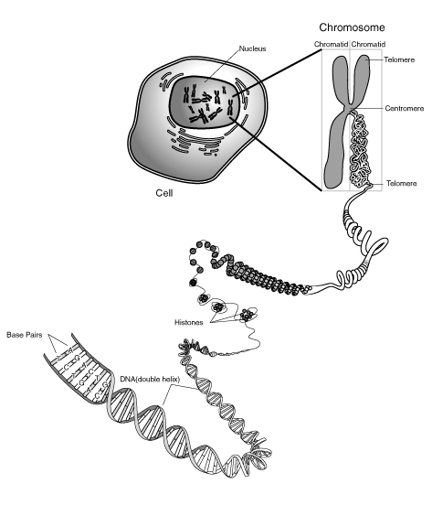
Organized by:
Kamineni Education Society, Kamineni Hospital,
L.B.Nagar,
Hyderabad, 500 068,

Andhra Pradesh
India.
Ph: + 04-3987 9999, 2402 2272, Fax: 24022277.
e-mail: gmdmm2009@gmail.com
kamineni@kamineni.org
Website: www.kaminenihospitals.com

MEDICAL AND GENETIC COUNSELING

(One year PG certificate course)

The advent of genetic tests has had a tremendous effect on clinical diagnosis. Diseases, which were difficult to diagnose earlier, are now aided by genetic screening tests. These tests are new and not very well known among clinicians. More important, the implications of the results must be explained to the patient and relatives in a professional manner, since most of the times, the results have tremendous emotional impact on families. The education and counseling accompanying genetic testing is provided by genetic counselors in all developed countries, as this is essential for the decision-making process regarding testing and dealing with test outcomes. This professional training is being given for the first time in India.

Who Requires Genetic Counselling?
The traditional emphasis on providing information coupled with supportive counseling is primarily for people wanting to know whether the disease is hereditary, whether other family members are susceptible and also to know if a therapeutic treatment option is right for them. Parents having one genetically abnormal child, or frequent abortions, generally want to know if the new pregnancy will give them a healthy child.
The contemporary areas where genetic analysis is useful are:
- Any Familial Disorder
- Cancer genetics
- Infertility, Artificial Reproduction Techniques and pre-implantation genetics
- Neurogenetics and psychiatric genetics
- Common adult disorders (e.g., cardiac diseases, diabetes, BP, asthma, etc)
- Genetics in the primary care setting – birth defects and mental retardation
- Research in infectious diseases – TB, HPV, etc
- Industry, including commercial laboratories and pharmaceutical companies

Role of a Genetic Counselor:
A genetic counselors must not only convey to individuals and their families information about diseases or problems they harbor but also the consequences of testing and the potential for therapeutic intervention, also enumerate the risks to other family members both in present and future generations. This is laden with uncertainty and raise difficult ethical, legal and social issues. Genetic counselors play a key role in educating health providers and assisting with establishing standards of practice. Trained genetic counselors also provide a liaison for health professionals and patients to communicate with policy makers, the media and the public about new and emerging medical/ genetic technologies and services.
Course Design:
This is a well-designed course on “Medical and Genetic Counseling” which is being offered in collaboration with the faculty of University of California, USA. This is a new and upcoming service oriented course with theory, practical and hospital based components. On completion of the course, candidates will be able to counsel families with medical and genetic problems and help as liaisons between clinicians and lab services. Will be able to work in Hospitals, Nursing Homes, Research Institutes, Industries and Clinical Research Labs.

There are limited seats, which will be filled strictly on Merit Basis

(SELF-FINANCED COURSE)
Eligibility: Masters in Genetics / Biochemistry / Biotechnology /
Life Sciences / Microbiology/Nursing or MBBS/BDS with a First Division

For further details contact:

Department of Genetics and Molecular Medicine

Kamineni Hospitals, L B Nagar, Hyderabad

Phone: 040 - 39879999, Extn : 210

